Lightsaber Project- Aanya & Emma

Project Design Document

1. Design Intent
- What experience are you trying to create?
  - We’re creating a Star Wars simulation experience through a video game and lightsaber controller.
  - The lightsaber will have a controllable NeoPixel strip so users can choose a colour and “character” (Eg: Red means dark side, green means Jedi)
  - The lightsaber will act as a hybrid weapon, whose physical movements will be used to hit enemy drones on a video game screen
- Who is it for?
  - Target users: Film enthusiasts, sci-fi enthusiasts, children
- If solving a problem, what problem does it solve?
  - Not solving a problem but interpreting the Star Wars technology and worldbuilding in our way, using what we have learnt.

2. Inspiration & References
- Existing products / ideas
  - Star Wars lightsaber from the movies
  - Tie-fighters from the Star Wars movies (used in our video game)
  - Lightsaber toys
  - Star Wars video games
  - PlayStation Move Controller

- Images / links
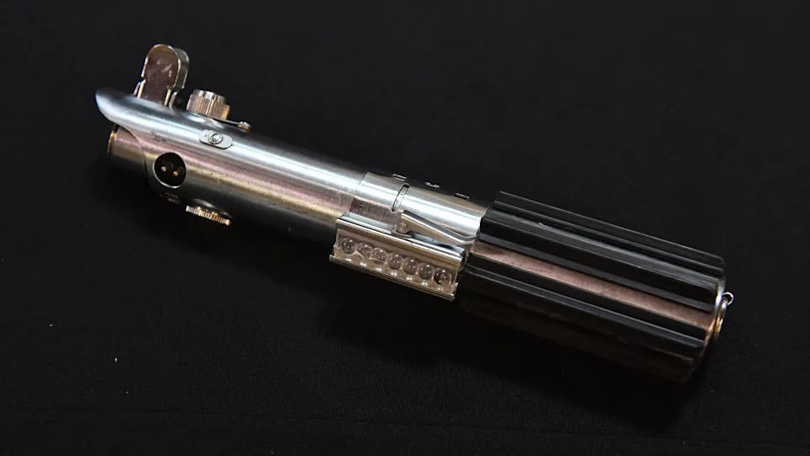
Hilt design inspiration: Luke Skywalker’s original Lightsaber hilt

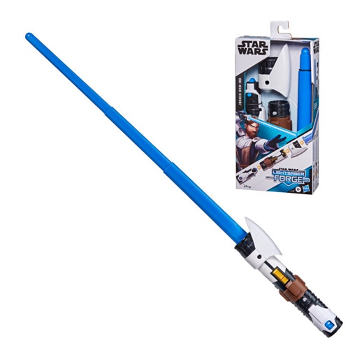
Source: Toyworld Australia

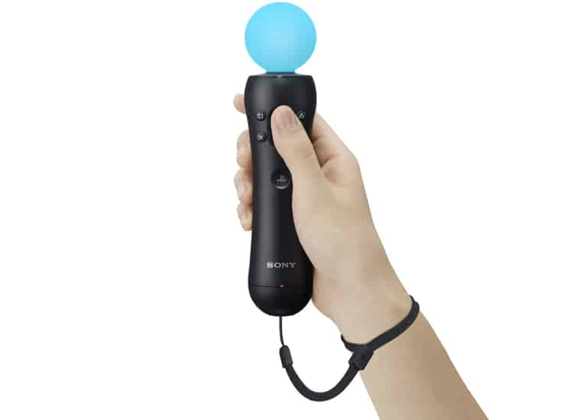
PS Move Controller

- What did you learn from them?
  - Lightsaber hilt design (We’re using Luke Skywalker’s original hilt design- the design was taken from a vintage camera’s flash part)
  - Purpose of the video game- To fight off tie-fighters
  - How we want the lightsaber to operate- same gesture function as PS Move

3. User Journey
Step-by-step experience of the user:
- User connects to the ESP32 Wi-Fi for basic instructions
- User holds the hilt, activating the lightsaber via LDR (Default colour = white)
- The user can choose from 4 colours using the push button
- When the user clicks start, the webpage changes from instructions to the video game where tie-fighters move towards user onscreen.
- User moves the lightsaber, represented by a pointer onscreen, to hit the tie-fighters. The lightsaber acts as their remote control.
👉 Think like storytelling

4. Success Criteria
Define measurable success:
- Technical:
  - LDR responds to hand on the hilt (darkness)
  - NeoPixel activates instantly (within 500ms) when user covers LDR on the hilt
  - Push button successfully cycles through 4 different colours, with one click signaling one colour change
- Gameplay:
  - Movement of the onscreen pointer corresponds to movement of the lightsaber in real life (low latency)
  - The MPU 6050 provides a full range of motion, allowing the user to reach all 4 corners of the screen with minimal drifting
  - Game does not crash, lag or ESP32 does not drop connection mid-game.
- User experience:
  - Users are able to navigate from the “Instructions” webpage to “Video Game” page without verbal assistance.
  - Users can hold the hilt in such a way that LDR and push button are accessible
  - Users can hit at least 5 targets
- Mechanical:
  - The hilt holds its cylindrical shape
  - The light sequence is clearly seen

5. System Overview
- High-level explanation of system
Our lightsaber is used as a gesture controller for a browser-based video game. The activation is intuitive, triggered by a Light Dependent Resistor (LDR) while players can select their colour with the push button. The buzzer adds auditory feedback.
Once ready, the player opens the video game and hits the tie-fighters as they come up onscreen. A pointer on screen corresponds to MPU-6050 data in the hilt of the remote-saber. The game continues for 90s, in which the player must hit as many targets as possible. If they miss 3 targets, the game ends.
The lightsaber operates as a simulative remote control, mirroring the Star Wars video game.

- What are the main parts?
- NeoPixel strip to show colour
- Light Dependent Resistor (LDR) to detect the user’s hand (darkness)
- Push button to change colours
- Wi-Fi capabilities to connect to a browser video game
- MPU 6050 for gesture data

6. High-Level Block Diagram

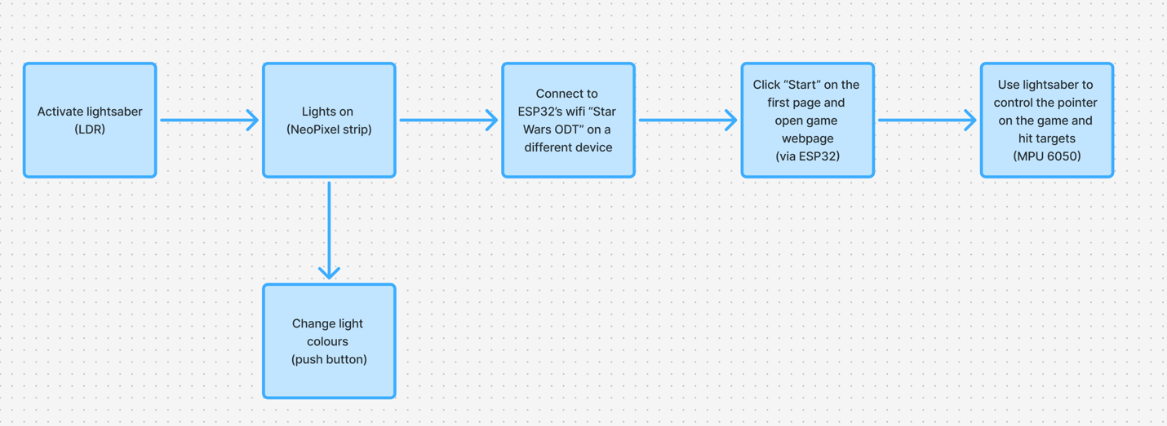

7. Input / Output Mapping
Input | Process | Output
MPU 6050 | Gyroscope measures degrees/s  Accelerometer measures wrist tilt  Used to determine coordinates and move the pointer according to user’s gestures | Pointer moves on video game
Push button | Calls a different colour from a list of 4 colours on each press of the button | NeoPixel strip
HTML code | Connect to ESP32’s Wi-Fi and open browser page | 1. Instructions webpage  2. Video game
Light Dependent Resistor | Darkness detection (hand on hilt) | Neopixel strip

Sketches & Concepts
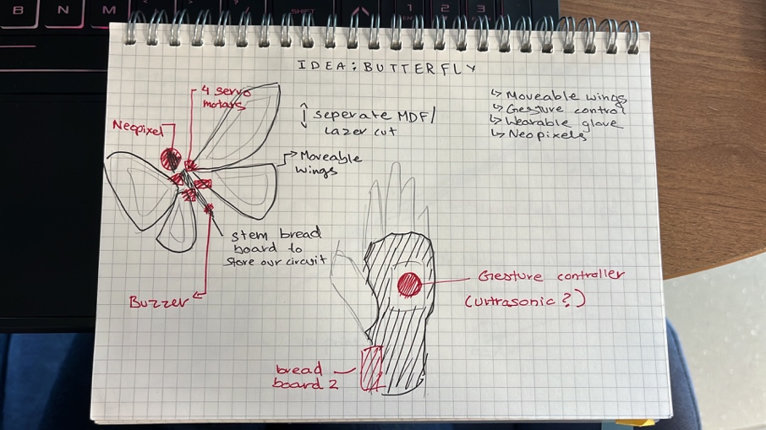
Our first idea: A levitating butterfly
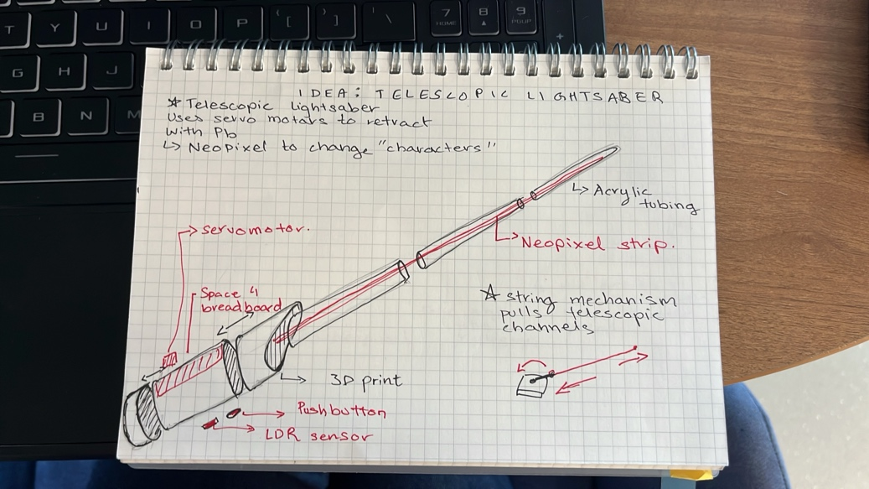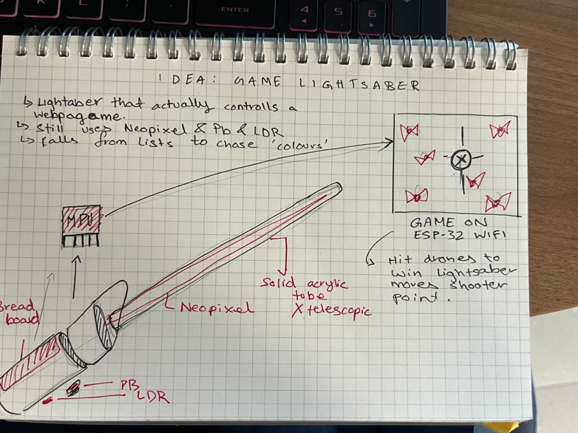
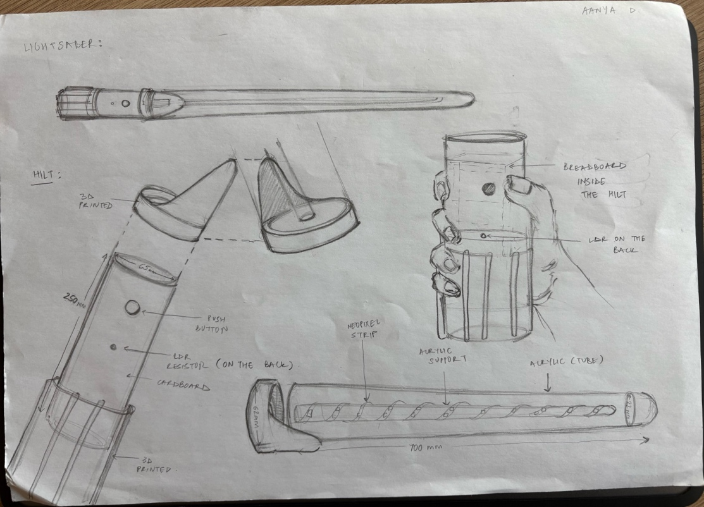
Our final idea: Lightsaber
We started with a retractable lightsaber with feedback and developed it into a motion controller.

8. Final System Architecture (Labelled)
